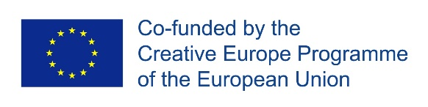
PUSH+ OPEN CALL
LAB 1: HOME
23 January – 1 February 2019

Application Form

Name
Address
Email
Website (if relevant)
Mobile phone

Please write a short (max 250 word) biography about you and your work. (This will be used on the PUSH website alongside your photograph if selected for the Lab: http://www.pushproject.eu/artists/). We are interested in who you are as an artist rather than a cv list of productions.

We have three questions for you, you are welcome to submit your answers in writing using this form or by video if preferred. If you are submitting video or audio responses, please put the link (and password if applicable) as your answer in the relevant question.

- Please tell us about your interest and experience in making theatre or dance for young audiences giving examples of work/projects you have been involved with:

- Tell us why you are interested in exploring the theme of HOME, giving examples of relevant projects you have been involved in and/or about topics you would like to investigate:

- Please tell us why you would like to take part in the Lab and what impact you hope it might have on your practice:

To apply:
First of all, read the accompanying Guidelines so you know what we are looking for. Please email this application form with a good quality photograph of yourself* (this will be used on the project website if you are selected for the Lab) to TheArkDublin@gmail.com by 5pm on Wednesday 24 October.

If you would prefer to fill out this form online, you can find it here.

CVs and additional documents won’t be shared with the panel so include all that you want us to know, including any web links to your work, within this application. Filmed answers should be uploaded to Vimeo or Youtube as password protected links.

*Images should be sent as jpeg files, at least 300DPI in quality and 2MB in size and should be in landscape orientation.

Data Protection: Any information that you are supplying in this application will be used only for the purposes of this application process. Unsuccessful applications will be retained for a maximum of 3 months. You can see more information on how we look after your data in our Privacy Statement.

